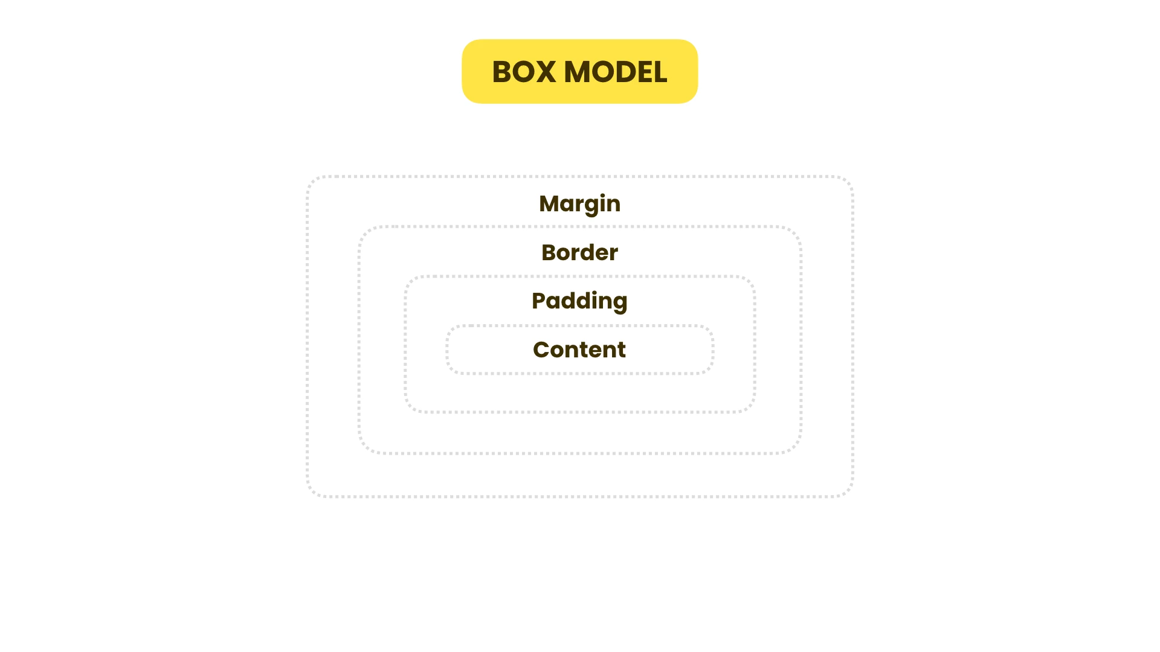

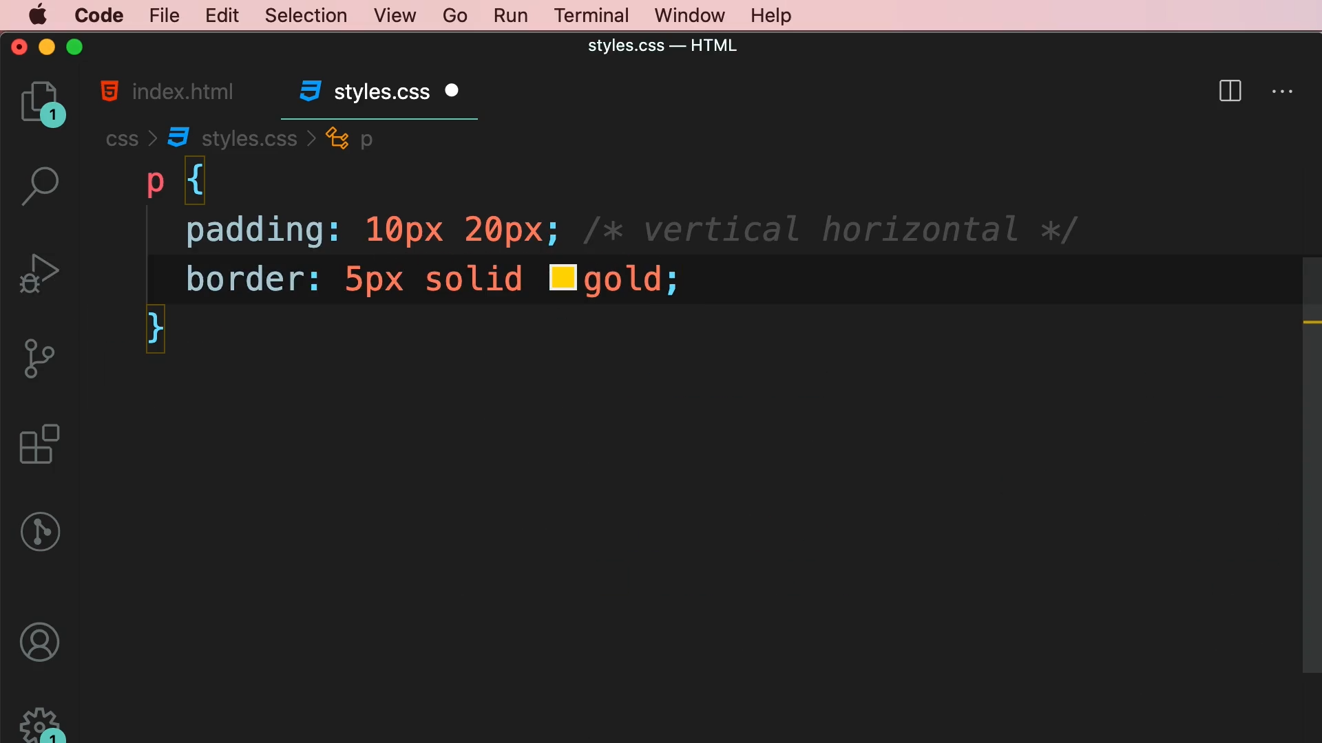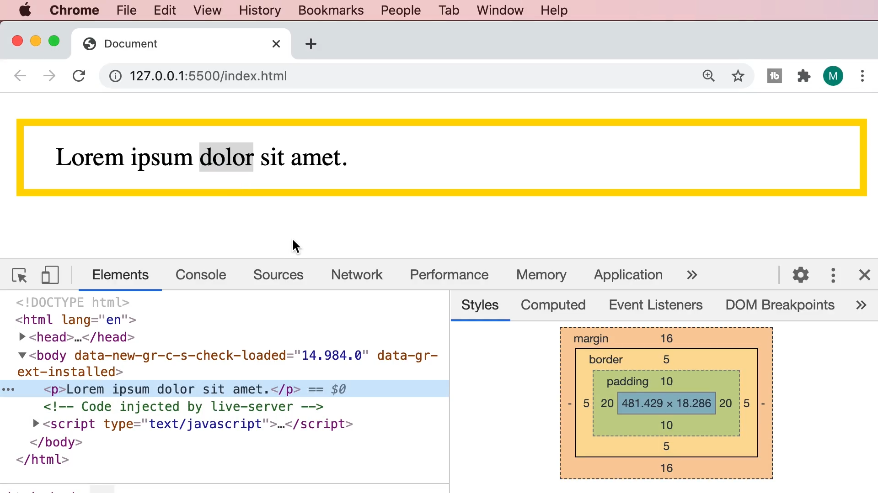  
  
By default, margin collapses but padding does not collapse.

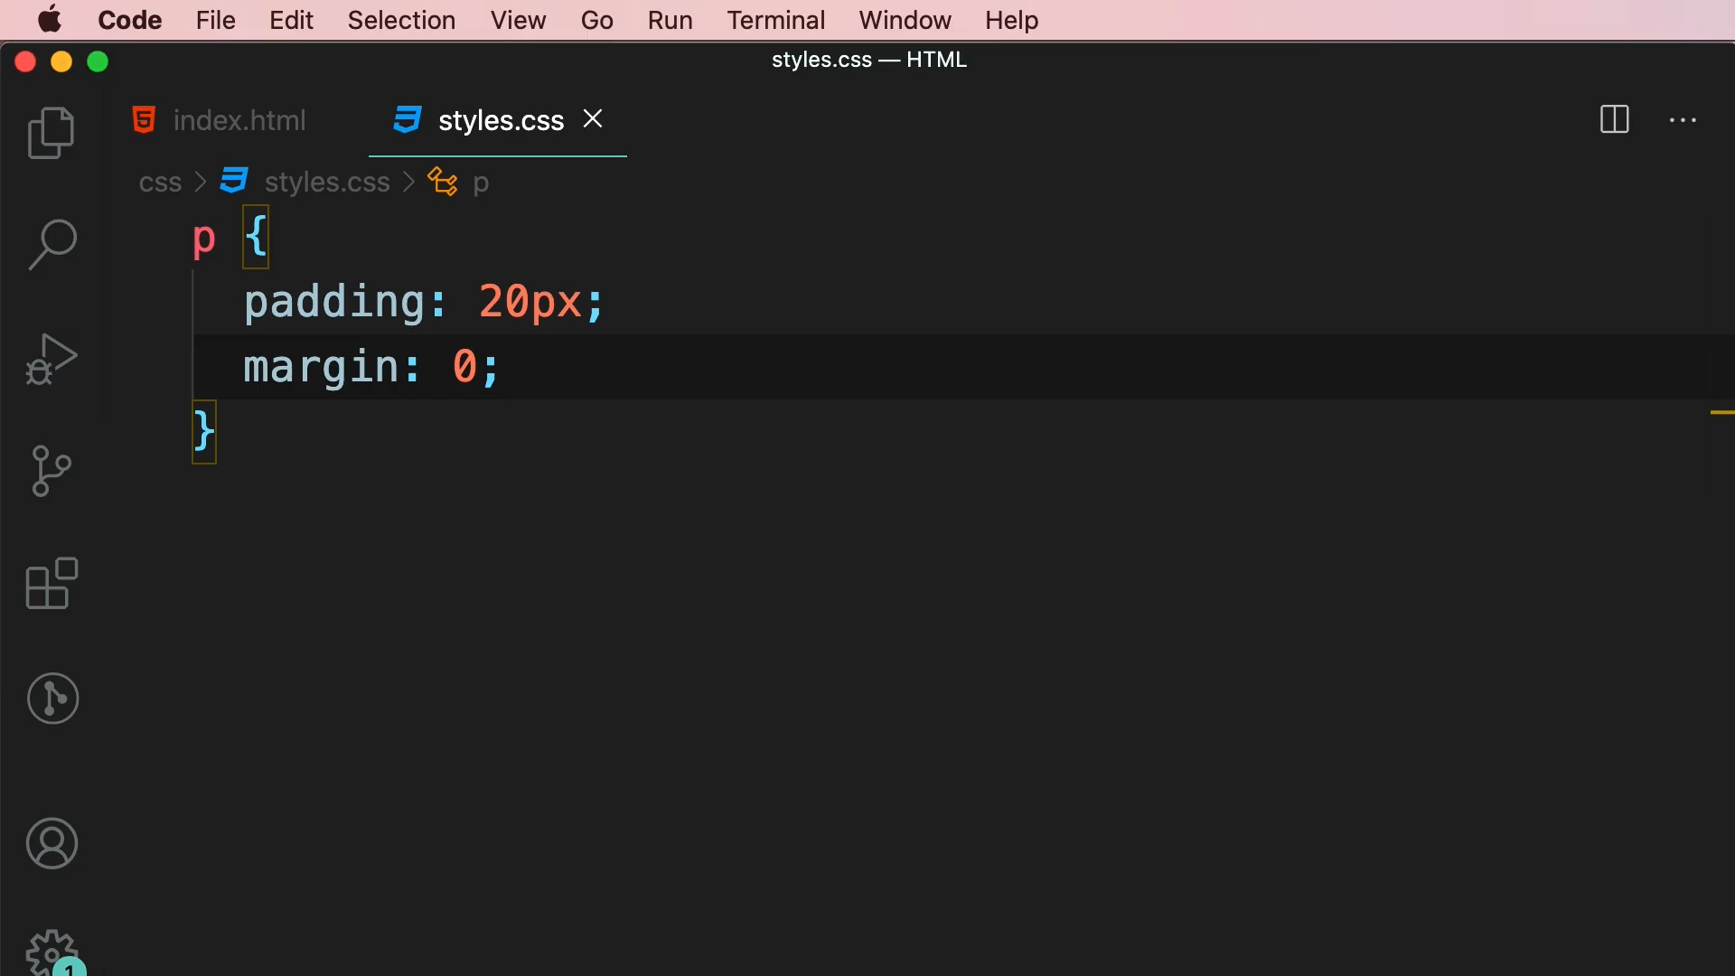

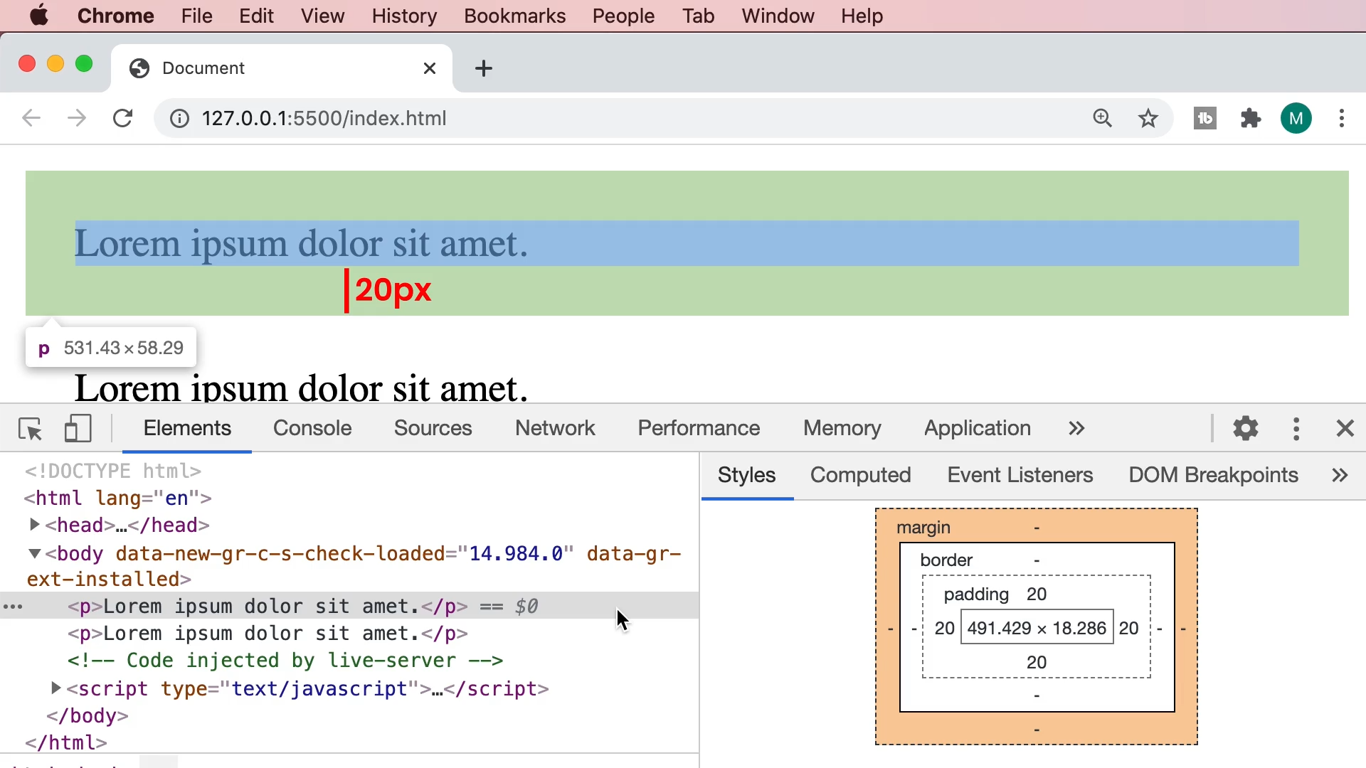

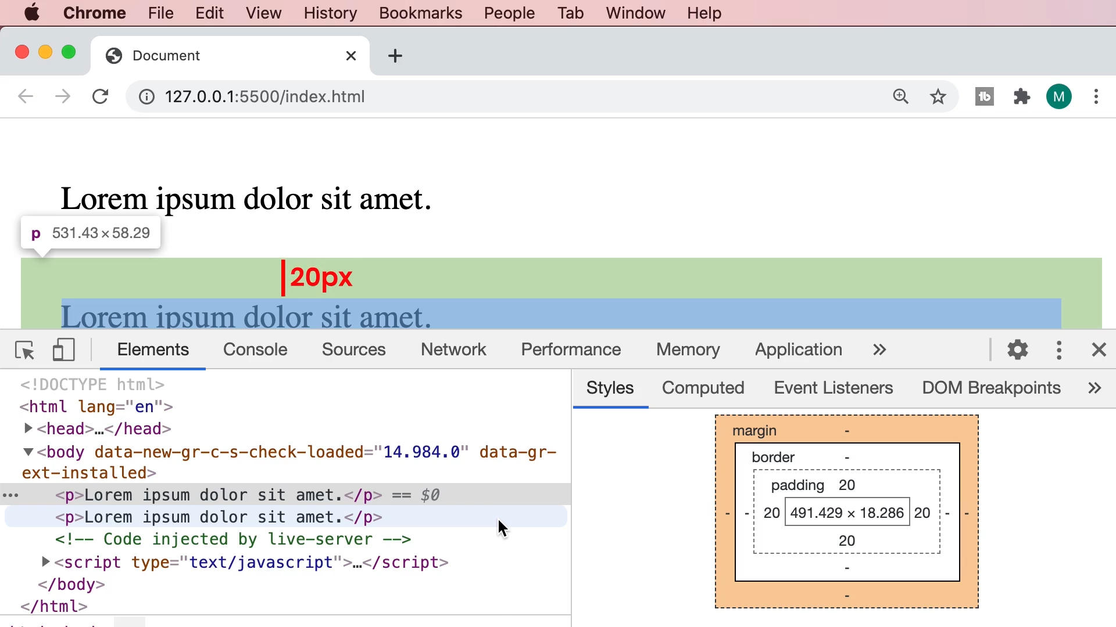

The total space between two paragraphs is 40px.

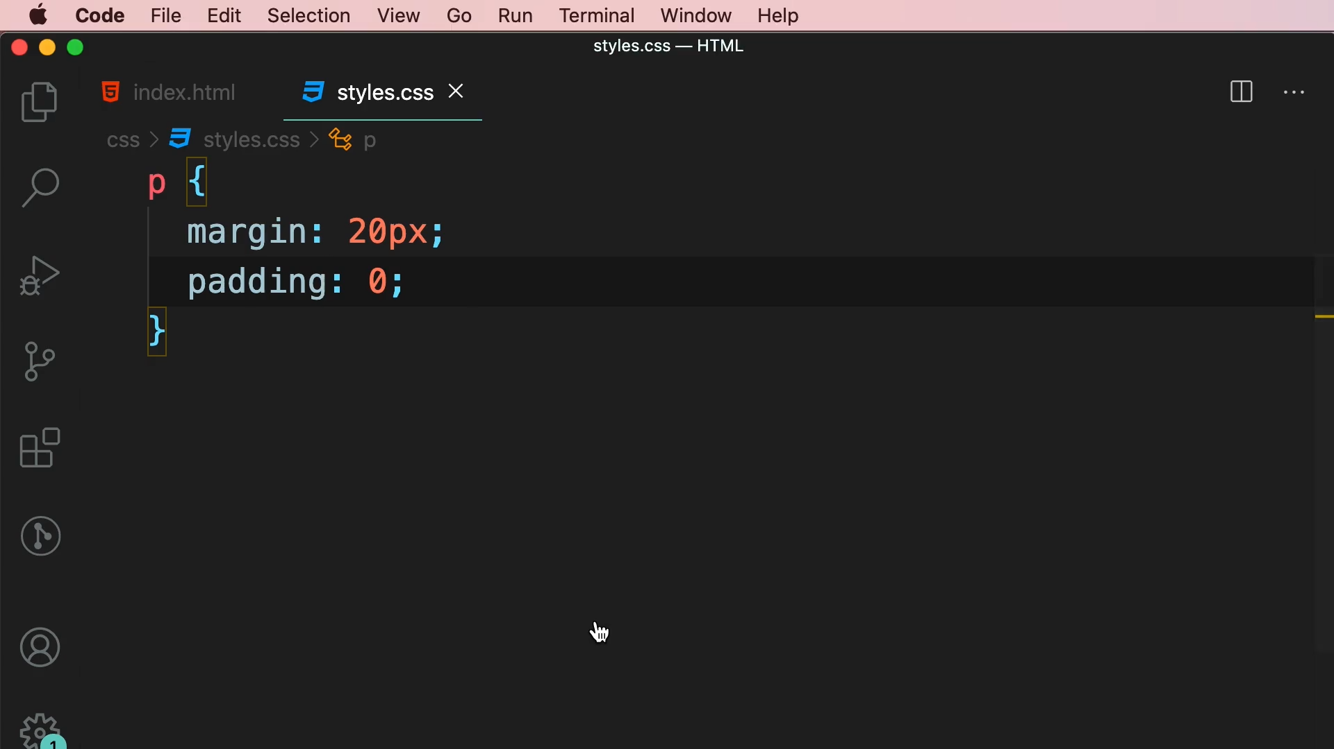

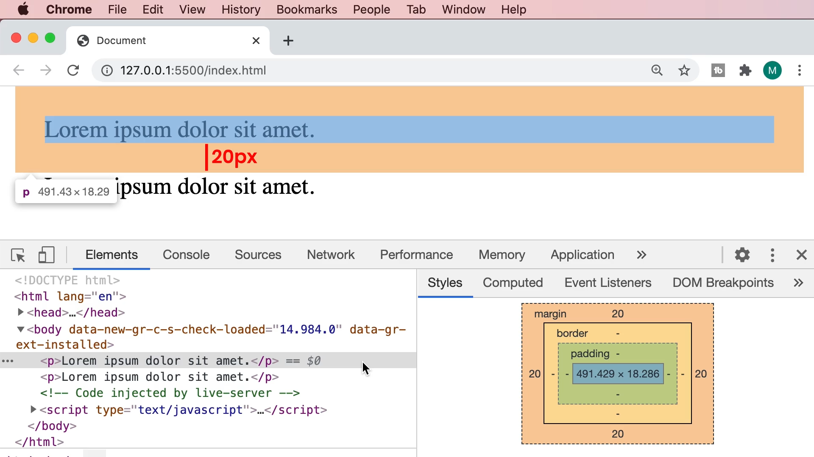

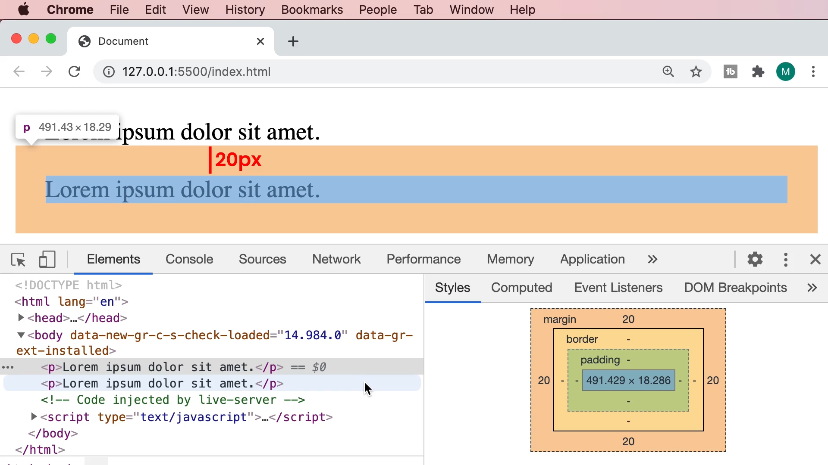

box-sizing in CSS

"Box-sizing" is a CSS property that determines how the total width and height of an HTML element is calculated, especially in relation to padding and borders. It can have one of two values:

content-box (default)

This is the default value. When an element's box-sizing is set to "content-box," the width and height of the element are calculated based on the content, excluding padding and borders. In other words, the padding and border are added to the width and height.

border-box

When an element's box-sizing is set to "border-box," the width and height of the element include both the content, padding, and borders. In this mode, the padding and border are considered part of the box's dimensions, and the content area is adjusted accordingly.  
  
box-sizing in Tailwind CSS

|  |  |
| --- | --- |
| Class | Properties |
| box-border | box-sizing: border-box; |
| box-content | box-sizing: content-box; |